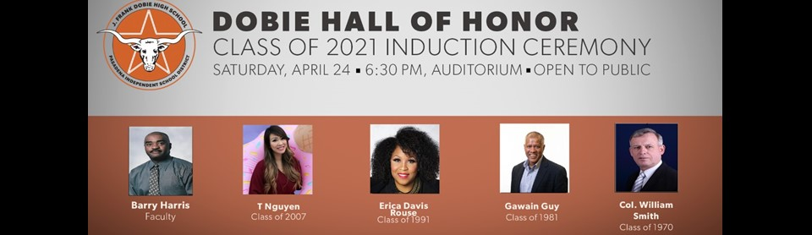
The honorees are:
Barry Harris - Faculty
Barry Harris made an impact on every student as an English teacher at Dobie for 20 years. He gave his time and talents to volunteering with the McDonald's Invitational Basketball tournament each year and he was named Volunteer of the Year in 2015 for his many contributions to the tournament. After he passed away in June 2018, the campus butterfly garden was dedicated in his name and a scholarship fund was also created in his name to continue his legacy of commitment to education.
T Nguyen -Class of 2007
With millions of followers, YouTube sensations T Nguyen and Princess Pham of “Princess ToysReview” built an empire, combining social media and children’s entertainment. Nguyen, whose roots run deep in the Dobie community, having attended Burnett Elementary, Thompson Intermediate and Dobie High School, returns to her alma mater regularly to give back to her fellow Longhorn community. Over the past several years, she has hosted toy donation events at Dobie for students attending campuses in the South Belt area. The sisters also started a foundation in honor of their sister who passed away.
Erica Davis Rouse-Class of 1991
Erica Davis Rouse always had a passion for serving students and the community. A graduate of Texas A&M University, Rouse has amassed over 15 years of professional sales experience, serving the majority of that time in management for AllHere Education, School Innovations and Achievement and John Wiley & Sons. Over the years, Rouse has volunteered for several educational and non-profit organizations, including serving as a Board of Trustee for the San Jacinto College District and as an advisory board member for the Smahrt Girl Foundation. Rouse has served Pasadena ISD as a team mom for several of her son's activities, including mentoring and coaching in the Leaders of Tomorrow program. She has volunteered for several non-profit organizations including Making it Better Texas.org and Yellowstone Academy and tutors at New Covenant Church. Rouse is a proud ambassador for the Houston Texans as a member of the Cheerleaders Alumni Organization.
Gawain Guy- Class of 1981
Gawain Guy was a record-breaking track and cross country standout. As a junior at Dobie, he won the 800 meters at the state track meet. As a senior, he doubled the distance and established himself as one of the top runners in the nation -- leading Dobie to the 1981 state track title. He won a whopping total of three state titles, one in cross country, one in the 800 meters and one in the 1600, where he clocked the fastest time in the nation and was ranked as the No. 1 miler in the land by “Track and Field News.” His achievements in track and cross country didn’t end there. Twice during his running days at Rice, he won the NCAA title in the indoor 1,000 meters, earning All-American honors in the process. Outdoors, he won the SWC 880 title in 1985. He still holds the Rice record in the metric mile. He doubled his successes, earning him a spot in the Rice Athletics Hall of Fame in 1998 and in the Pasadena ISD Athletics Hall of Fame in 2013. Guy competed in the first round of the 1984 Olympics for his native home, Jamaica. He earned his B.A. from Rice and for the past 18 years, he has served as VP of sales at CT Design and Equipment, a food and beverage service firm in Indianapolis.
Col. William Smith- Class of 1970
After graduating from Dobie High School in 1970, Colonel William Smith went on to attend the University of Texas at Austin, along with the Marine Corps Officer Candidates School. Upon his graduation in 1974, Smith was commissioned as a Marine Second Lieutenant.
A few months later in 1975, he participated in the raid on Koh Tang Island Cambodia to recover the SS Mayaguez and crew, the last combat operation of the war in southeast Asia. Smith continued to actively serve for the next 29 years on a variety of assignments including Director, Drill Instructor of School Parris Island; United Nations Peacekeeper, U.S. Military Observer Group Palestine; Commanding Officer, Officer Candidates School; and Director, Coalition and Special Warfare Center, along with various senior staff assignments at the Pentagon. After rising to the rank of Colonel, Smith retired from active service in 2004. Shortly after, he was hired at LMI, a government consultancy that assists both U.S. and foreign governments. While serving with the consultancy, he served as Director of International Programs; General Manager in Saudi Arabia; Regional Director, in North Africa, with on-site management responsibilities in Tripoli to assist the Government of Libya; and Program Manager for a year-long effort in Iraq.
Colonel Smith is a distinguished graduate of the Naval War College and holds a Master of Arts in National Security and Strategic Studies, a Master of Business Administration and a Bachelor of Business Administration in Finance. Smith currently resides in Virginia with his family. He serves as the Chairman of the Board of Directors of the Young Marines and holds lifetime memberships in the Veterans of Foreign Wars, American Legion and the Military Officers Association of America.

